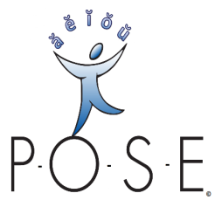www.P-O-S-E.com | P-O-S-E Inc.  50 Willow Street  Garden City, NY 11530  Phone (516) 248-POSE (248-7673)  Fax (516) 640-5115  Federal I.D. / NYS Resale # 32-0380528  Sales@ P-O-S-E.com | BID / PROPOSAL  BID Number P [00000]
 |  | Date of bid / PROPOSAL: 4/30/2015

BILL TO: | Att: Jane Smith, Ed.D.  Pupil Personnel Director  Praetoria UFSD  123 43rd Street  Praetoria NY 10203  551-248-7673  Fax: 551-640-5115 8422 | BID REQUEstED BY: | Att: Jane Smith, Ed.D.  Pupil Personnel Director  Praetoria UFSD  123 43rd Street  Praetoria NY 10203  551-248-7673  Fax: 551-640-5115 8422

SHIPPING METHOD | SHIPPING TERMS | Terms
U.S.P.S. Priority Mail | n/a | Net 30 days

qty | item # | description |  | unit price | line total
1 | A | P-O-S-E Phonological-Orthographic Substitution Evaluation Basic Test Kit and Site License |  | $245.00 | $245.00
1 | E | Basic Angling Practice Book: Decoding & Spelling Practice w/ Basic Vocabulary (Academic Therapies Press) |  | $12.00 | $12.00
1 | F | Vowel-O-Phone |  | $14.75 | $14.75
 |  |  |  | subtotal |  | $271.75
Prices quoted are guaranteed for 90 days. Our terms are net 30 days |  |  |  | SaLES TAX |  | Exempt
 |  |  |  | Payment/Credit
wHEN PLACING YOUR ORDER, PLEASE Provide Tax EXEMPTION # |  |  |  | Shipping |  | $14.00
sIGNED: cAROL A., sULLIVAN, m.s., pRESIDENT 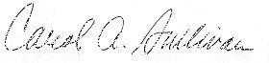 |  |  |  | total |  | $285.75

